January 10th, 2024

**Request for Information (RFI) Related to NIST's Assignments Under Sections 4.1, 4.5 and 11 of the Executive Order Concerning Artificial Intelligence (Sections 4.1, 4.5, and 11)**

SAE International welcomes the opportunity to comment on the Request for Information related to NIST's Assignments Under Sections 4.1, 4.5 and 11 of the Executive Order Concerning Artificial Intelligence (Sections 4.1, 4.5, and 11). This response relates to assignment 1. Developing Guidelines, Standards, and Best Practices for AI Safety and Security and assignment 3. Advance Responsible Global Technical Standards for AI Development and specifically provides information that NIST is seeking regarding topics related to the development and implementation of AI-related consensus standards.

SAE International is a non-profit organization head quartered in the United States and the largest non-government mobility standards developing organization in the world providing a neutral forum to develop industry consensus standards that advance safety, quality, and innovation, thus advancing mobility engineering throughout the world. The SAE Technical Standards Development Program is now – and has been for over a century – the organization’s primary provision to those mobility industries it serves aerospace, automotive, and commercial vehicles. Today’s SAE standards product portfolio includes almost 10,000 active and current documents created through a robust and transparent stakeholder consensus standards development process by more than 240 SAE Technical Committees with 450+ subcommittees and task groups. These works are authorized, revised, and maintained by the efforts of more than 14,000 technical experts, and other qualified professionals, consisting of representatives from industry, government, and academia.

The SAE Executive Standards Committee (ESC) oversees and governs the activities of 9 SAE standards Councils for Aerospace, Systems Management, Automotive, Commercial Vehicle and Off-Highway mobility and which in turn provide the governance, oversight, and strategy for SAE’s standards programs.

SAE International is part of a larger eco-system through Fullsight, which also encompasses the Performance Review Institute (PRI) and SAE Industry Technologies Consortia (SAE ITC). The Group provides additional industry-government programs based on consensus standards to assure critical and emerging technologies, such as consortia and conformity assessment of facilities, processes and products.

SAE’s G-34 Artificial Intelligence in Aviation Committee together with EUROCAE WG-114 Artificial Intelligence Working Group brings together over 500 global experts with the objective of establishing common standards and guidance material required to support the development and the certification/approval of aeronautical safety-related products based on AI-technology.

Background

Anticipating a growing commercial pressure for Artificial Intelligence (AI) solutions within the aerospace industry over the coming years, there is an urgent call for regulation and the emergence of norms around acceptable usage. SAE International established the G-34 technical standards committee in May 2019 to address the use of AI in aviation and provide the necessary standards and recommended practices to facilitate technology development and certification. G-34 was subsequently joined by EUROCAE WG-114 and the joint working group, comprised of experts across industry, governments and academia, is evaluating key applications for AI usage within aeronautical systems, with a scope encompassing ground-based equipment and airborne vehicles, including Unmanned Aircraft Systems (UAS) products. In terms of processes, the full lifecycle is under consideration, from design and manufacturing, to operation and through-life maintenance. A key deliverable will be documented standards, providing guidance on assuring safe and secure systems utilizing AI, through an agreed acceptable means of compliance with regulatory requirements.

The first objective of the joint working group was to develop and publish a technical report, a comprehensive Statement of Concerns (SOC), outlining the scope and purpose of the group’s work and considering the concerns before imagining the solutions. Thus, AIR6988/ER-022 Artificial Intelligence in Aeronautical Systems: Statement of Concerns was published in April 2021. The document reviews current aerospace software, hardware, and system development standards used in the certification/approval process of safety-critical airborne and ground-based systems and assesses whether these standards are compatible with a typical Artificial Intelligence (AI) and Machine Learning (ML) development approach. The document then outlines what is required to produce a standard that provides the necessary accommodation to support integration of ML-enabled sub-systems into safety-critical airborne and ground-based systems, and details next steps in the production of such a standard.

Current work

AI has the potential to disrupt the aerospace industry, impacting all areas in which computing and aerospace intersect. AI technologies are becoming progressively more embedded into the digital systems used to design, manufacture, operate, and maintain both aerial vehicles and ground-based systems. Leveraged appropriately, AI-driven solutions could transform the products and services that aerospace companies provide with an accelerated pace of change. Specifically, Machine Learning (ML) technologies have the potential to revolutionize established paradigms of aeronautical system development, including those concerned with safety-critical applications.

The joint committee is now developing the Aerospace Recommended Practice - **ARP6983 Process Standard for Development and Certification/Approval of Aeronautical Safety-Related Products Implementing AI.**  It is anticipated that the document will be published later this year.

The purpose of this document is to provide guidance for the development of Artificial Intelligence (AI) technology for aeronautical systems and equipment that performs its intended function with a level of confidence in safety that complies with airworthiness requirements. This version of the standard is largely domain-agnostic and gathers generic process assurance guidance for the development of any aeronautical systems (software and/or hardware) using non-adaptive ML techniques.

The intended users of the Recommended Practice are developers, applicants, and regulators for aeronautical systems using embedded ML requiring certification. The document additionally may be useful for the development of non-certificated products.

The methodology that the joint committees are using to build an AI Aerospace Standard is depicted in the figure below.

**HIGH LEVEL METHODOLGY TO BUILD THE STANDARD**

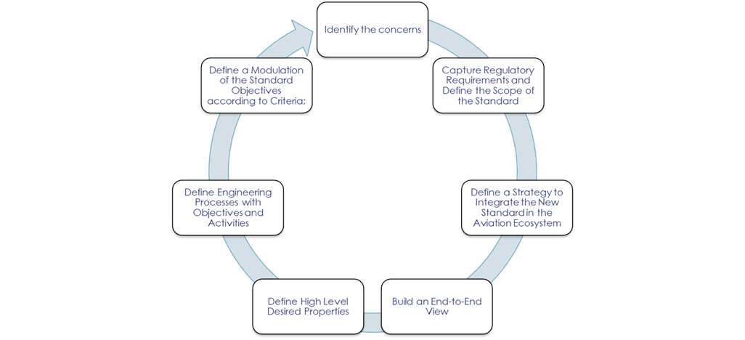

To support ARP6983 an Aerospace Information Report (AIR6987) will soon be published which will provide definitions for commonly used terms in the discussion of artificial intelligence applications and present a classification of artificial intelligence techniques.

Next Activities

ARP6983 will continue to be a ‘living’ document, so once the first edition of the Aerospace Recommend Practice is published the Committee will immediately begin work on the next revision which will be an Aerospace Standard. As the regulatory authorities mature their AI policies over time as well as technology maturation, so too will the standards mature, moving from focusing on non-adaptive ML techniques to AI.

It is important that standards development organizations have visibility of and are involved in relevant research activities and have access to data and analysis so that there is a seamless pipeline from research through to standards development. This then will help accelerate standards development in Artificial Intelligence.

SAE International appreciates the opportunity to comment on the RFI and if we can be of further assistance, please do not hesitate to contact me at [Jonathan.Archer@sae.org](mailto:Jonathan.Archer@sae.org)

*J Archer*

Jonathan Archer

Director, Aerospace Standards Strategy & Innovation